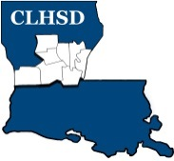
CLHSD Board of Directors

Special Meeting via ZOOM
Februrary 24 @ 12:45 p.m.
Phone: 1-216- 706-7052
Code – 444706 / Meeting ID – 847 8975 4805 / PW- 502373

- Call Special Meeting to Order/ Quorum

- Board Resolution

- Adjourn (vote)

